**CARESTREAM HEALTH**

|  |  |
| --- | --- |
| **Part Number :** | **Autour : Ralf Wang** |
| **Project : KIOSK PUMA System** | **Product : KIOSK** |
| **Document Title: Kiosk PUMA Performance Testing Report\_20170601** | |

**TABLE OF CONTENTS**

[1 Test Environment 2](#_Toc484421685)

[2 Test Requirement 2](#_Toc484421686)

[2.1 Test Scenario 3](#_Toc484421687)

[2.2 Test Tool 3](#_Toc484421688)

[3 Testing work （Phase 1） 4](#_Toc484421689)

[3.1 Strategy and Scenario Setting 4](#_Toc484421690)

[3.2 Background Data 4](#_Toc484421691)

[3.3 Other Setting: 5](#_Toc484421692)

[3.3.1 Database setting 5](#_Toc484421693)

[3.3.2 IIS setting 5](#_Toc484421694)

[3.4 Test Object version 5](#_Toc484421695)

[3.5 Test Error 5](#_Toc484421696)

[3.6 Test result 6](#_Toc484421697)

[3.6.1 Transactions result 6](#_Toc484421698)

[3.6.2 Test Statistic Report 6](#_Toc484421699)

[3.6.3 Transaction summary result: 7](#_Toc484421700)

[3.6.4 Transaction response time result 7](#_Toc484421701)

[3.7 Performance bottleneck analysis 8](#_Toc484421702)

[3.7.1 Hardware usage analysis 8](#_Toc484421703)

[3.7.2 SQL Server resource usage analysis 10](#_Toc484421704)

[3.8 Test Conclusion 12](#_Toc484421705)

[3.9 Tune Suggesting 12](#_Toc484421706)

[3.9.1 Slowly SQL statement 12](#_Toc484421707)

[3.9.2 Deadlock SQL 14](#_Toc484421708)

[3.9.3 Other 14](#_Toc484421709)

# Test Environment

Test environment：We use the follow machine to do our performance testing work.

|  |  |  |  |  |  |  |  |  |  |  |  |
| --- | --- | --- | --- | --- | --- | --- | --- | --- | --- | --- | --- |
| **Server Name** | **Type** | **CPU** | | **Hard Disk** | | **RAM** | | **OS** | | **Required Software** | |
| PS Server | Hyper-v virtual machine | Intel Xeon E5-2620 v3 2.40GHz \*12 | 2T SCSI Disk  Seagate MD3002 | | 32G | | Windows 2012 R2 | | SQL 2012  IIS 8 | |
| QTP script machine | Hyper-v virtual machine | Intel Xeon E5-2403 v2 1.80GHz \*4 | 80G Virtual Disk | | 2.5G | | Windows 2012 R2 | | QTP 11 demo | |
| Performance control | Dell optiplex 9020 | Intel core(TM) i7-4790 3.6GHZ\*6 | 1T SATA Disk | | 8G | | Win7 64bit | | Load runner | |

Figure 1.1 Hardware List

# Test Requirement

The PUMA system will support reporting and notice push service for different department of entire hospital. We will integrate with the 3rd party system and patients can print their reports in ONE terminal. The message push service will also be included in the product. Patient can query different information and get the report status notice service from the product.

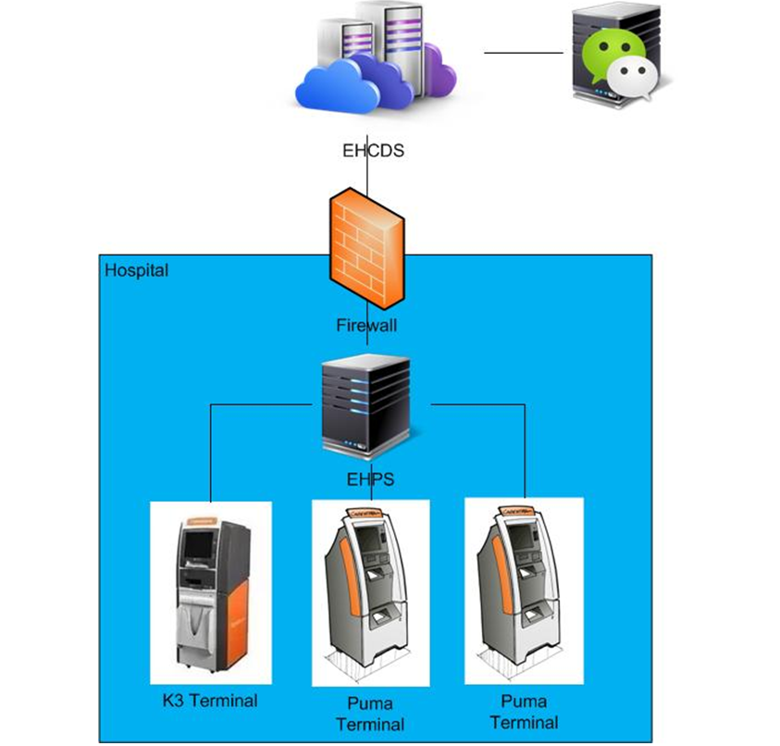

Figure2.1 System structure

We will do the performance testing work to make sure the system can fit the requirements and services work well. The detail plan and strategy please reference the content in document “AE4746\_PUMA\_Verification Test Plan.docx”.

## Test Scenario

The testing work will simulate the real work flow include Print film from workstation, Query and operation in web, OCR operations, terminal print, message push and etc.

## Test Tool

QTP: Simulate doctor print film from workstation.

Load Runner: Simulate the doctor and patient operation by http or web service.

# Testing work （Phase 1）

## Strategy and Scenario Setting

1. Use automation tool simulate the doctor print film work. Simulate 8 GX Platform by using QTP and PDSender tool. Each client prints one film which size is 10MB every 30 seconds.
2. Use LR tool simulate 10 K2/K3 terminals to print film. Each client prints one film which size is 10MB random 5 to 30 seconds.
3. Use LR tool simulate 45 PUMA terminals to print paper reports. Each client prints report random 5 to 30 seconds.
4. Use LR tool simulate the PUMA report archive operations. Each client archive report in random 5 to 30 seconds and size is random with 100kb and 4Mb.
5. The OCR setting is cover the rule for GX platforms in step1 and other setting are set as default.
6. Monitor the hardware resource usage on PS.
7. Monitor the resource usage for database on PS.
8. Start/Stop 2 virtual users every 5 seconds and run the scenario for 2 hours.

## Background Data

We use SQL command statement to add large data in the database, the detail information as follow:

|  |  |
| --- | --- |
| **Table Name** | **Data Volume (records)** |
| printer.dbo.DeliveryJob | 896813 |
| printer.dbo.ImageBox | 997879 |
| printer.dbo.Page | 997813 |
| printer.dbo.Session | 1001132 |
| wggc.dbo.Patient | 1029777 |
| wggc.dbo.Study | 1029789 |
| wggc.dbo.AFP\_PrintTerminalInfo | 62 |
| wggc.dbo.Series | 1029735 |
| wggc.dbo.Image | 1029738 |
| wggc.dbo.AFP\_FilmInfo | 1043592 |
| wggc.dbo.AFP\_ReportInfo | 936761 |
| wggc.dbo.AFP\_ExamInfo | 1997005 |
| wggc.dbo.AFP\_PrintTask | 3696324 |
| wggc.dbo.T\_Integration\_ExamInfo | 119292 |
| AFP\_PrintMode | 87883 |
| wggc.dbo.vi\_KIOSK\_ExamInfo\_Order | 119331 |

Figure 3.2.1 Background Data

## Other Setting:

### Database setting

Memory: Set the min and max memory size to 8GB.

Index fill factor: 80.

File: Increase the data and log files size and the rule is increase 200Mb as fixed size.

### IIS setting

Connection: Set the max connection value to 4000 and keep other setting as default.

## Test Object version

KIOSK Platform 3.0.0.1 B05

## Test Error

There are some errors exist in the testing work and logged as follow:

|  |  |  |
| --- | --- | --- |
| No | description | Counts |
| 1 | "HttpSendRequest" failed, Windows error code=12002 and retry limit (0) exceeded for URL="http://10.184.129.208/EHDPS/printtask/print/3982374?tid=K2\_6" | 9 |
| 2 | HTTP Status-Code=404 (Not Found) for "http://10.184.129.208/EHDPS/printtask/print/?tid=K2\_2" | 13 |
| 3 | HTTP Status-Code=503 (Service Unavailable) for "http://10.184.129.208/EHDPS/printtask/status/3982245?tid=K2\_1" | 6 |
| 4 | No match found for the requested parameter "TaskStatus". Check whether the requested boundaries exist in the response data. Also, if the data you want to save exceeds 10240 bytes, use web\_set\_max\_html\_param\_len to increase the parameter size | 25 |
| 5 | The above "not found" error(s) may be explained by header and body byte counts being 0 and 0, respectively. | 7 |
| 6 | Text=<NotifyReportFileResult>true</NotifyReportFileResult>" not found for web\_reg\_find | 168 |
| 7 | The task do not finished!: \*\*\*\*\*\* From Terminal: \*\*\*\*\*\*\*\*\* | 1006 |

Error analyzes:

1. Http request do not execute successfully, there is some error in IIS.
2. Send the request and server return 404 errors, the print transaction failed. Some errors happened in IIS or database.
3. The IIS error rule limits the server to response. There are many error happens in IIS, then IIS refuse the service.
4. Some requests do not return the response context. The scripts cannot get the value from the response context and it makes the script down.
5. Some requests do not return the response.
6. The notify report service do not execute successfully, the transaction is failed.
7. The errors is make from scripts, it means the print tasks do not print successfully.

## Test result

### Transactions result

After the testing work, the transaction result which collect from database as follow:

|  |  |  |  |
| --- | --- | --- | --- |
| **Transaction** | **All** | **Pass** | **Fail** |
| All Print Tasks | 6575 | N/A | N/A |
| Film print task | 769 | 709 | 60 |
| Report print task | 5803 | 4883 | 920 |
| Report archive | 10770 | N/A | N/A |

Figure 3.6.1.1 Transaction result from DB

### Test Statistic Report

|  |  |  |
| --- | --- | --- |
| **Scenario Name:** | Scenario PUMA | |
| **Duration:** | | 2 hours, 13 minutes and 1 second. |

|  |
| --- |
| Statistics Summary |

|  |  |  |
| --- | --- | --- |
| [**Maximum Running Vusers:**](file:///C:\Users\Administrator\Desktop\Performance%20result\20170531_1\VuserStateGraph) |  | 100 |
| [**Total Throughput (bytes):**](file:///C:\Users\Administrator\Desktop\Performance%20result\20170531_1\Throughput) |  | 26,305,565,808 |
| [**Average Throughput (bytes/second):**](file:///C:\Users\Administrator\Desktop\Performance%20result\20170531_1\Throughput) |  | 3,295,611 |
| [**Total Hits:**](file:///C:\Users\Administrator\Desktop\Performance%20result\20170531_1\HitsperSecond) |  | 75,058 |
| [**Average Hits per Second:**](file:///C:\Users\Administrator\Desktop\Performance%20result\20170531_1\HitsperSecond) |  | 9.403 |  |
| [**Total Errors:**](file:///C:\Users\Administrator\Desktop\Performance%20result\20170531_1\TotalErrorsPerSecond) |  | 1,234 |  |

|  |
| --- |
| Transaction Summary |

|  |  |  |  |  |
| --- | --- | --- | --- | --- |
| [**Transactions:**](file:///C:\Users\Administrator\Desktop\Performance%20result\20170531_1\TransactionSummary) | Total Passed: 90,627 | Total Failed: 1,202 | Total Stopped: 0 | [**Average Response Time**](file:///C:\Users\Administrator\Desktop\Performance%20result\20170531_1\ResponseTime) |

|  |  |  |  |  |  |  |  |  |  |
| --- | --- | --- | --- | --- | --- | --- | --- | --- | --- |
| **Transaction Name** | **SLA Status** | **Minimum** | **Average** | **Maximum** | **Std. Deviation** | **90 Percent** | **Pass** | **Fail** | **Stop** |
| [Film Create\_PrintTask](file:///C:\Users\Administrator\Desktop\Performance%20result\20170531_1\ResponseTime0000(Film%20Create_PrintTask)0000) |  | 0.04 | 0.407 | 11.454 | 0.632 | 0.794 | 989 | 1 | 0 |
| [Film PrintTask](file:///C:\Users\Administrator\Desktop\Performance%20result\20170531_1\ResponseTime0000(Film%20PrintTask)0000) |  | 0.059 | 0.884 | 11.887 | 1.086 | 1.658 | 987 | 3 | 0 |
| [Film PrintTask\_Check](file:///C:\Users\Administrator\Desktop\Performance%20result\20170531_1\ResponseTime0000(Film%20PrintTask_Check)0000) |  | 0.01 | 0.447 | 29.884 | 1.203 | 0.83 | 5,272 | 24 | 0 |
| [Film PrintTask\_Result](file:///C:\Users\Administrator\Desktop\Performance%20result\20170531_1\ResponseTime0000(Film%20PrintTask_Result)0000) |  | 0 | 0 | 0 | 0 | 0 | 0 | 288 | 0 |
| [Film TerminalStatus](file:///C:\Users\Administrator\Desktop\Performance%20result\20170531_1\ResponseTime0000(Film%20TerminalStatus)0000) |  | 0.019 | 0.468 | 8.512 | 0.599 | 1.073 | 1,980 | 0 | 0 |
| [Notify File 100k](file:///C:\Users\Administrator\Desktop\Performance%20result\20170531_1\ResponseTime0000(Notify%20File%20100K)0000) |  | 1.576 | 15.165 | 106.73 | 9.877 | 22.015 | 238 | 3 | 0 |
| [Notify File 4M](file:///C:\Users\Administrator\Desktop\Performance%20result\20170531_1\ResponseTime0000(Notify%20File%204M)0000) |  | 0.454 | 16.026 | 124.852 | 11.987 | 24.059 | 11,682 | 165 | 0 |
| [Report Create\_PrintTask](file:///C:\Users\Administrator\Desktop\Performance%20result\20170531_1\ResponseTime0000(Report%20Create_PrintTask)0000) |  | 0.027 | 0.503 | 40.779 | 1.402 | 0.907 | 5,583 | 0 | 0 |
| [Report Download File](file:///C:\Users\Administrator\Desktop\Performance%20result\20170531_1\ResponseTime0000(Report%20Download%20File)0000) |  | 0.027 | 1.794 | 36.419 | 1.425 | 3.359 | 5,583 | 0 | 0 |
| [Report PrintTask](file:///C:\Users\Administrator\Desktop\Performance%20result\20170531_1\ResponseTime0000(Report%20PrintTask)0000) |  | 0.1 | 3.823 | 54.344 | 4.423 | 7.351 | 5,583 | 0 | 0 |
| [Report PrintTask\_Check](file:///C:\Users\Administrator\Desktop\Performance%20result\20170531_1\ResponseTime0000(Report%20PrintTask_Check)0000) |  | 0.011 | 0.406 | 39.1 | 1.207 | 0.776 | 19,234 | 0 | 0 |
| [Report QueryFilmReportInfo](file:///C:\Users\Administrator\Desktop\Performance%20result\20170531_1\ResponseTime0000(Report%20QueryFilmReportInfo)0000) |  | 0.004 | 0.062 | 15.485 | 0.289 | 0.11 | 11,166 | 0 | 0 |
| [Report Task Result](file:///C:\Users\Administrator\Desktop\Performance%20result\20170531_1\ResponseTime0000(Report%20Task%20Result)0000) |  | 0 | 0 | 0 | 0 | 0 | 0 | 718 | 0 |
| [Report TerminalStatus](file:///C:\Users\Administrator\Desktop\Performance%20result\20170531_1\ResponseTime0000(Report%20TerminalStatus)0000) |  | 0.016 | 0.489 | 17.066 | 0.859 | 1.05 | 11,166 | 0 | 0 |
| [Report Update PrintTask](file:///C:\Users\Administrator\Desktop\Performance%20result\20170531_1\ResponseTime0000(Report%20Update%20PrintTask)0000) |  | 0.282 | 5.733 | 48.45 | 5.367 | 11.366 | 5,581 | 0 | 0 |
| [Report Update report printer info](file:///C:\Users\Administrator\Desktop\Performance%20result\20170531_1\ResponseTime0000(Report%20Update%20report%20printer%20info)0000) |  | 0.028 | 0.562 | 29.721 | 0.817 | 1.17 | 5,583 | 0 | 0 |

Figure 3.6.2.1 Summary Report

Follow the summary result information; we can get the information that:

All testing work duration time is 2 hours and 13 minutes. There are 90627 transactions passed and 1202 transactions failed. The follow transactions` response times are not meets the requirements and value is too big:

|  |  |  |  |  |  |  |  |  |  |
| --- | --- | --- | --- | --- | --- | --- | --- | --- | --- |
| **Transaction Name** | **SLA Status** | **Minimum** | **Average** | **Maximum** | **Std. Deviation** | **90 Percent** | **Pass** | **Fail** | **Stop** |
| [Notify File 100k](file:///C:\Users\Administrator\Desktop\Performance%20result\20170531_1\ResponseTime0000(Notify%20File%20100K)0000) |  | 1.576 | 15.165 | 106.73 | 9.877 | 22.015 | 238 | 3 | 0 |
| [Notify File 4M](file:///C:\Users\Administrator\Desktop\Performance%20result\20170531_1\ResponseTime0000(Notify%20File%204M)0000) |  | 0.454 | 16.026 | 124.852 | 11.987 | 24.059 | 11,682 | 165 | 0 |
| [Report PrintTask](file:///C:\Users\Administrator\Desktop\Performance%20result\20170531_1\ResponseTime0000(Report%20PrintTask)0000) |  | 0.1 | 3.823 | 54.344 | 4.423 | 7.351 | 5,583 | 0 | 0 |
| [Report Update PrintTask](file:///C:\Users\Administrator\Desktop\Performance%20result\20170531_1\ResponseTime0000(Report%20Update%20PrintTask)0000) |  | 0.282 | 5.733 | 48.45 | 5.367 | 11.366 | 5,581 | 0 | 0 |

Figure 3.6.2.2 big value of response time

The team should focus on the tuning works to enhance the service performance and find out the reason why some transactions are failed.

### Transaction summary result:

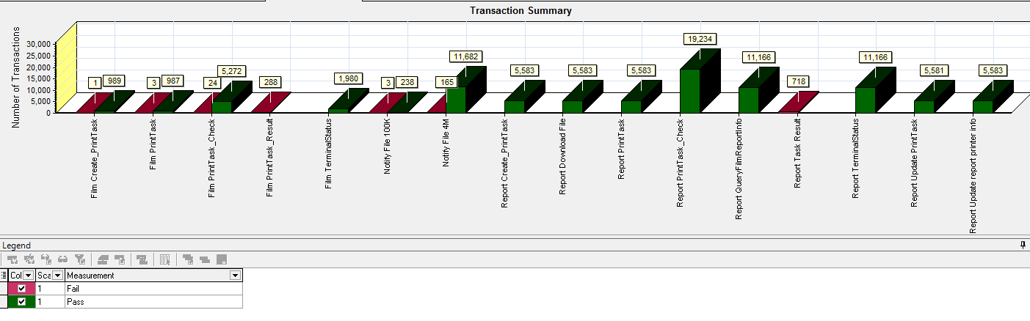

Figure 3.6.3.1 Transaction Summary

We can notice that there are some transactions failed during the testing work. We should find out the reason and fix it in the next version.

### Transaction response time result

We can get the transaction response time information from the figure as follow:

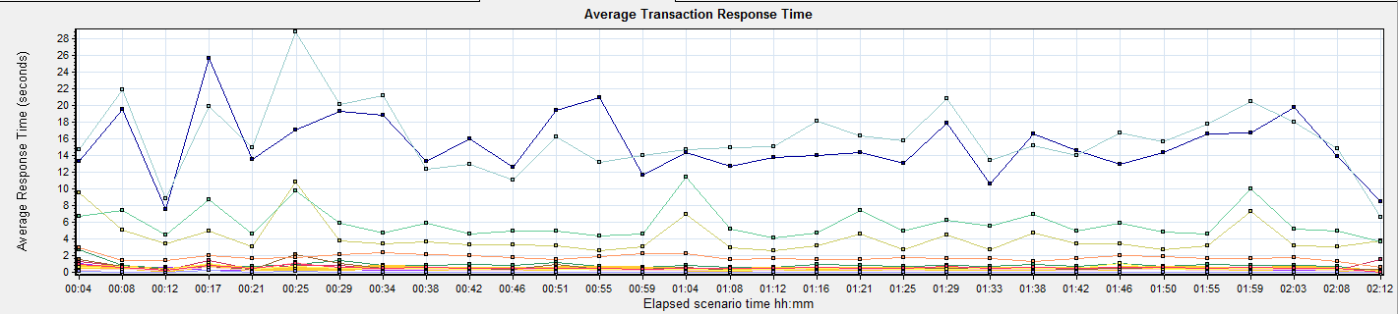

|  |  |  |  |  |  |  |  |  |  |  |  |  |  |  |  |  |  |  |  |  |  |  |  |  |  |  |  |  |  |  |  |  |  |  |  |  |  |  |  |  |  |  |  |  |  |  |  |  |  |  |  |  |  |  |  |  |  |  |  |  |  |  |  |  |  |  |  |  |  |  |  |  |  |  |  |  |  |  |  |  |  |  |  |  |  |  |  |  |  |  |  |  |  |  |  |  |  |  |  |  |  |  |  |  |  |  |  |  |  |  |  |  |  |  |  |  |  |  |  |  |
| --- | --- | --- | --- | --- | --- | --- | --- | --- | --- | --- | --- | --- | --- | --- | --- | --- | --- | --- | --- | --- | --- | --- | --- | --- | --- | --- | --- | --- | --- | --- | --- | --- | --- | --- | --- | --- | --- | --- | --- | --- | --- | --- | --- | --- | --- | --- | --- | --- | --- | --- | --- | --- | --- | --- | --- | --- | --- | --- | --- | --- | --- | --- | --- | --- | --- | --- | --- | --- | --- | --- | --- | --- | --- | --- | --- | --- | --- | --- | --- | --- | --- | --- | --- | --- | --- | --- | --- | --- | --- | --- | --- | --- | --- | --- | --- | --- | --- | --- | --- | --- | --- | --- | --- | --- | --- | --- | --- | --- | --- | --- | --- | --- | --- | --- | --- | --- | --- | --- | --- | --- |
| |  |  |  |  |  |  |  |  | | --- | --- | --- | --- | --- | --- | --- | --- | | **Color** | **Scale** | **Measurement** | **Graph's Minimum** | **Graph's Average** | **Graph's Maximum** | **Graph's Median** | **Graph's Std. Deviation** | |  | 1 | Film Create\_PrintTask | 0.06 | 0.396 | 1.082 | 0.364 | 0.165 | |  | 1 | Film PrintTask | 0.168 | 0.897 | 2.686 | 0.862 | 0.397 | |  | 1 | Film PrintTask\_Check | 0.245 | 0.507 | 1.594 | 0.352 | 0.341 | |  | 1 | Film TerminalStatus | 0.165 | 0.46 | 0.804 | 0.447 | 0.123 | |  | 1 | Notify File 4M | 7.601 | 15.299 | 25.731 | 14.368 | 3.702 | |  | 1 | Notify File 100k | 6.607 | 16.115 | 28.851 | 15.153 | 4.146 | |  | 1 | Report Create\_PrintTask | 0.312 | 0.563 | 2.21 | 0.399 | 0.396 | |  | 1 | Report Download File | 0.639 | 1.791 | 3.007 | 1.726 | 0.403 | |  | 1 | Report PrintTask | 2.598 | 4.167 | 10.881 | 3.444 | 1.953 | |  | 1 | Report PrintTask\_Check | 0.077 | 0.375 | 1.226 | 0.339 | 0.177 | |  | 1 | Report QueryFilmReportInfo | 0.038 | 0.067 | 0.255 | 0.051 | 0.049 | |  | 1 | Report TerminalStatus | 0.105 | 0.496 | 1.126 | 0.458 | 0.207 | |  | 1 | Report Update PrintTask | 3.694 | 5.906 | 11.482 | 5.019 | 1.858 | |  | 1 | Report Update report printer info | 0.072 | 0.569 | 1.114 | 0.536 | 0.185 | |
|  |

Figure 3.6.4.1 Transaction response time

This figure information shows all transaction response time. We can analysis that there are four transaction time is very big which mentioned in chapter 3.6.2. There are : Notify File 4m, Notify File 100k, Report Print Task and Report Update Print Task. The service for these transactions should enhance.

## Performance bottleneck analysis

### Hardware usage analysis

During the testing work, we use the test tool to monitor the server hardware usage include the CPU, Memory, hard disk and etc.

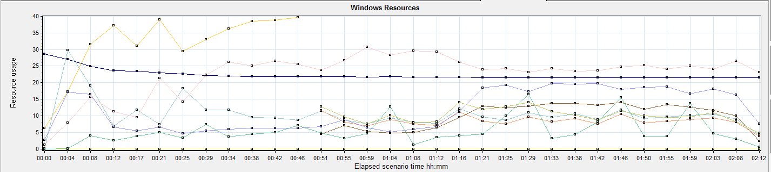

|  |  |  |  |  |  |  |
| --- | --- | --- | --- | --- | --- | --- |
| **Color** | **Scale** | **Measurement** | **Minimum** | **Average** | **Maximum** | **Std. Deviation** |
|  | 0.1 | % Disk Read Time (PhysicalDisk \_Total):10.184.129.208 | 0 | 104.067 | 1843.83 | 109.482 |
|  | 0.01 | % Disk Time (PhysicalDisk \_Total):10.184.129.208 | 1.865 | 1057.717 | 47176.98 | 1699.254 |
|  | 0.01 | % Disk Write Time (PhysicalDisk \_Total):10.184.129.208 | 55.1 | 857.615 | 4116.794 | 504.563 |
|  | 1 | % Processor Time (Processor \_Total):10.184.129.208 | 4.059 | 31.383 | 78.454 | 13.647 |
|  | 0.001 | Available MBytes (Memory):10.184.129.208 | 21266 | 22360.382 | 28699 | 1646.69 |
|  | 1 | Avg. Disk Queue Length (PhysicalDisk \_Total):10.184.129.208 | 0.019 | 10.577 | 471.77 | 16.993 |
|  | 10 | Avg. Disk Read Queue Length (PhysicalDisk \_Total):10.184.129.208 | 0 | 1.041 | 18.438 | 1.095 |
|  | 1 | Avg. Disk Write Queue Length (PhysicalDisk \_Total):10.184.129.208 | 0.551 | 8.576 | 41.168 | 5.046 |
|  | 1 | Current Disk Queue Length (PhysicalDisk \_Total):10.184.129.208 | 0 | 10.379 | 58 | 8.309 |
|  | 0.001 | Page Faults/sec (Memory):10.184.129.208 | 112.97 | 22389.925 | 72649.68 | 11624.931 |
|  | 1 | Page Reads/sec (Memory):10.184.129.208 | 0 | 11.65 | 207.454 | 11.089 |
|  | 1 | Page Writes/sec (Memory):10.184.129.208 | 0 | 0 | 0 | 0 |
|  | 10 | Processor Queue Length (System):10.184.129.208 | 0 | 0.554 | 60 | 3.644 |

Follow this information we can get that:

The CPU usage do not exist bottleneck, the average process time is 31% and max value is 78%. All value is less than 80%.The average process queue length is 0.5, it less than 24(CPU count \* 2), so the CPU resource is enough.

The memory available value is 22.3G and the system use 6.3 G. The memory do not has bottleneck as current testing stress.

|  |
| --- |
| We notice that the disk time is 1057(% Disk Time), it means the disk is very busy. Most time is cost on write operation (% Disk Write Time 857). Because we simulate the report archived operations, it will write the report files to local disk. |

*4M\*11,682 transaction count/2hours/60minute/60seconds = 6.49Mb/seconds.*

The notify report service will use the disk resource with 6.5 Mb/seconds; system also need do some other disk operation during the testing work.

|  |  |  |  |  |  |  |
| --- | --- | --- | --- | --- | --- | --- |
| **Color** | **Scale** | **Measurement** | **Minimum** | **Average** | **Maximum** | **Std. Deviation** |
|  | 0.1 | % Disk Read Time (PhysicalDisk \_Total):10.184.129.208 | 0 | 104.067 | 1843.83 | 109.482 |
|  | 0.01 | % Disk Time (PhysicalDisk \_Total):10.184.129.208 | 1.865 | 1057.717 | 47176.98 | 1699.254 |
|  | 0.01 | % Disk Write Time (PhysicalDisk \_Total):10.184.129.208 | 55.1 | 857.615 | 4116.794 | 504.563 |
|  | 1 | % Idle Time (PhysicalDisk \_Total):10.184.129.208 | 0 | 10.248 | 98.711 | 18.714 |
|  | 0.0001 | Avg. Disk Bytes/Transfer (PhysicalDisk \_Total):10.184.129.208 | 4608 | 470190.952 | 2042554.182 | 261126.199 |
|  | 1 | Avg. Disk Queue Length (PhysicalDisk \_Total):10.184.129.208 | 0.019 | 10.577 | 471.77 | 16.993 |
|  | 10 | Avg. Disk Read Queue Length (PhysicalDisk \_Total):10.184.129.208 | 0 | 1.041 | 18.438 | 1.095 |
|  | 1 | Avg. Disk Write Queue Length (PhysicalDisk \_Total):10.184.129.208 | 0.551 | 8.576 | 41.168 | 5.046 |
|  | 1 | Current Disk Queue Length (PhysicalDisk \_Total):10.184.129.208 | 0 | 10.379 | 58 | 8.309 |
|  | 1E-06 | Disk Bytes/sec (PhysicalDisk \_Total):10.184.129.208 | 361235.425 | 26977575.43 | 59949809.535 | 8807127.049 |
|  | 1E-06 | Disk Read Bytes/sec (PhysicalDisk \_Total):10.184.129.208 | 0 | 9509305.421 | 42217025.513 | 6538140.809 |
|  | 1 | Disk Reads/sec (PhysicalDisk \_Total):10.184.129.208 | 0 | 13.507 | 101.852 | 9.606 |
|  | 0.1 | Disk Transfers/sec (PhysicalDisk \_Total):10.184.129.208 | 2.658 | 57.29 | 548.233 | 38.609 |
|  | **1E-06** | **Disk Write Bytes/sec (PhysicalDisk \_Total):10.184.129.208** | **317778.532** | **17522953.713** | **105466788.548** | **6923172.893** |
|  | 1 | Disk Writes/sec (PhysicalDisk \_Total):10.184.129.208 | 14.951 | 46.404 | 401.91 | 35.726 |
|  | 10 | Processor Queue Length (System):10.184.129.208 | 0 | 0.554 | 60 | 3.644 |

The average disk write counter value is 17.5Mb (Disk Write Bytes/sec); the disk is under big stress during the testing work.

The Page Faults/sec counter value is 22G, but the other page counter values are low. Normally, if this counter is high, it perhaps exist the memory leak. But we notice the memory usage in system is enough and do not reduce quickly, other page counter value is also low. So we consider it does not have the issues and it cause by the report download operation. The system will read the file and transfer to the client with http protocol.

### SQL Server resource usage analysis

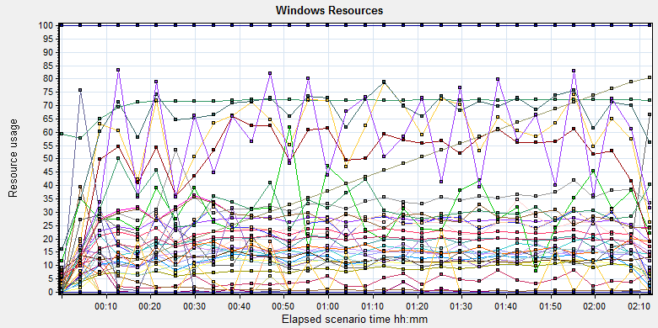

|  |  |  |  |  |  |  |  |  |  |  |  |  |  |  |  |  |  |  |  |  |  |  |  |  |  |  |  |  |  |  |  |  |  |  |  |  |  |  |  |  |  |  |  |  |  |  |  |  |  |  |  |  |  |  |  |  |  |  |  |  |  |  |  |  |  |  |  |  |  |  |  |  |  |  |  |  |  |  |  |  |  |  |  |  |  |  |  |  |  |  |  |  |  |  |  |  |  |  |  |  |  |  |  |  |  |  |  |  |  |  |  |  |  |  |  |  |  |  |  |  |  |  |  |  |  |  |  |  |  |  |  |  |  |  |  |  |  |  |  |  |  |  |  |  |  |  |  |  |  |  |  |  |  |  |  |  |  |  |  |  |  |  |  |  |  |  |  |  |  |  |  |  |  |  |  |  |  |  |  |  |  |  |  |  |  |  |  |  |  |  |  |  |  |  |  |  |  |  |  |  |  |  |  |  |  |  |  |  |  |  |  |  |  |  |  |  |  |  |  |  |  |  |  |  |  |  |  |  |  |  |  |  |  |  |  |  |  |  |  |  |  |  |  |  |  |  |  |  |  |  |  |  |  |  |  |  |  |  |  |  |  |  |  |  |  |  |  |  |  |  |  |  |  |  |  |  |  |  |  |  |  |  |  |  |  |  |  |  |  |  |  |  |  |  |  |  |  |  |  |  |  |
| --- | --- | --- | --- | --- | --- | --- | --- | --- | --- | --- | --- | --- | --- | --- | --- | --- | --- | --- | --- | --- | --- | --- | --- | --- | --- | --- | --- | --- | --- | --- | --- | --- | --- | --- | --- | --- | --- | --- | --- | --- | --- | --- | --- | --- | --- | --- | --- | --- | --- | --- | --- | --- | --- | --- | --- | --- | --- | --- | --- | --- | --- | --- | --- | --- | --- | --- | --- | --- | --- | --- | --- | --- | --- | --- | --- | --- | --- | --- | --- | --- | --- | --- | --- | --- | --- | --- | --- | --- | --- | --- | --- | --- | --- | --- | --- | --- | --- | --- | --- | --- | --- | --- | --- | --- | --- | --- | --- | --- | --- | --- | --- | --- | --- | --- | --- | --- | --- | --- | --- | --- | --- | --- | --- | --- | --- | --- | --- | --- | --- | --- | --- | --- | --- | --- | --- | --- | --- | --- | --- | --- | --- | --- | --- | --- | --- | --- | --- | --- | --- | --- | --- | --- | --- | --- | --- | --- | --- | --- | --- | --- | --- | --- | --- | --- | --- | --- | --- | --- | --- | --- | --- | --- | --- | --- | --- | --- | --- | --- | --- | --- | --- | --- | --- | --- | --- | --- | --- | --- | --- | --- | --- | --- | --- | --- | --- | --- | --- | --- | --- | --- | --- | --- | --- | --- | --- | --- | --- | --- | --- | --- | --- | --- | --- | --- | --- | --- | --- | --- | --- | --- | --- | --- | --- | --- | --- | --- | --- | --- | --- | --- | --- | --- | --- | --- | --- | --- | --- | --- | --- | --- | --- | --- | --- | --- | --- | --- | --- | --- | --- | --- | --- | --- | --- | --- | --- | --- | --- | --- | --- | --- | --- | --- | --- | --- | --- | --- | --- | --- | --- | --- | --- | --- | --- | --- | --- | --- | --- | --- | --- | --- | --- | --- | --- | --- | --- | --- | --- | --- | --- | --- | --- | --- | --- | --- | --- | --- | --- | --- | --- | --- | --- |
| |  |  |  |  |  |  |  | | --- | --- | --- | --- | --- | --- | --- | | **Color** | **Scale** | **Measurement** | **Minimum** | **Average** | **Maximum** | **Std. Deviation** | |  | 0.1 | Batch Requests/sec (MSSQL$GCPACSWS|SQL Statistics):10.184.129.208 | 4.651 | 255.989 | 1332.855 | 80.648 | |  | 1 | Buffer cache hit ratio (MSSQL$GCPACSWS|Buffer Manager):10.184.129.208 | 94.667 | 99.997 | 100 | 0.104 | |  | 1 | Cache Hit Ratio (MSSQL$GCPACSWS|Catalog Metadata WGGC):10.184.129.208 | 55.192 | 70.815 | 72.339 | 3.577 | |  | 0.001 | Cursor memory usage (MSSQL$GCPACSWS|Cursor Manager by Type \_Total):10.184.129.208 | 240 | 4556.62 | 18752 | 3426.99 | |  | 10 | Cursor Requests/sec (MSSQL$GCPACSWS|Cursor Manager by Type \_Total):10.184.129.208 | 0 | 5.866 | 31.23 | 4.01 | |  | 1 | Database Cache Size (MB) (Database svchost):10.184.129.208 | 0 | 0 | 0 | 0 | |  | 1 | Distributed Query (MSSQL$GCPACSWS|Exec Statistics Average execution time (ms)):10.184.129.208 | 0 | 2.782 | 716 | 23.743 | |  | 100 | Distributed Query (MSSQL$GCPACSWS|Exec Statistics Cumulative execution time (ms) per second):10.184.129.208 | 0 | 0.012 | 12 | 0.33 | |  | 100 | Distributed Query (MSSQL$GCPACSWS|Exec Statistics Execs in progress):10.184.129.208 | 0 | 0.006 | 10 | 0.217 | |  | 1E-17 | Distributed Query (MSSQL$GCPACSWS|Exec Statistics Execs started per second):10.184.129.208 | 0 | 2.23258627215849E+18 | 1.84467440737096E+19 | 6.01660253983545E+18 | |  | 1 | Errors/sec (MSSQL$GCPACSWS|SQL Errors \_Total):10.184.129.208 | 0 | 13.546 | 81.737 | 7.408 | |  | 1 | Errors/sec (MSSQL$GCPACSWS|SQL Errors User Errors):10.184.129.208 | 0 | 9.956 | 69.77 | 6.114 | |  | 1 | Extended Procedures (MSSQL$GCPACSWS|Exec Statistics Average execution time (ms)):10.184.129.208 | 0 | 0 | 0 | 0 | |  | 0.1 | Full Scans/sec (MSSQL$GCPACSWS|Access Methods):10.184.129.208 | 2.654 | 214.618 | 1006.711 | 99.882 | |  | 0.001 | Index Searches/sec (MSSQL$GCPACSWS|Access Methods):10.184.129.208 | 0 | 32976.584 | 587279.921 | 21183.07 | |  | 1000 | Latch waits/sec (MSOLAP$GCPACSWS|Locks):10.184.129.208 | 0 | 0.031 | 0.665 | 0.101 | |  | 1 | Lazy writes/sec (MSSQL$GCPACSWS|Buffer Manager):10.184.129.208 | 0 | 0 | 0 | 0 | |  | 1E-05 | Lock Requests/sec (MSSQL$GCPACSWS|Locks \_Total):10.184.129.208 | 0 | 827162.689 | 2539012.006 | 315313.265 | |  | 0.1 | Lock Timeouts/sec (MSSQL$GCPACSWS|Locks \_Total):10.184.129.208 | 0 | 175.637 | 527.516 | 88.695 | |  | 0.0001 | Lock Wait Time (ms) (MSSQL$GCPACSWS|Locks \_Total):10.184.129.208 | 0 | 235431.872 | 1450366.673 | 173747.617 | |  | 0.01 | Lock waits (MSSQL$GCPACSWS|Wait Statistics Average wait time (ms)):10.184.129.208 | 0 | 1579.483 | 21480 | 2213.928 | |  | 0.1 | Lock waits (MSSQL$GCPACSWS|Wait Statistics Waits in progress):10.184.129.208 | 0 | 237.348 | 527 | 117.584 | |  | 0.1 | Lock Waits/sec (MSSQL$GCPACSWS|Locks \_Total):10.184.129.208 | 0 | 115.725 | 400.368 | 61.581 | |  | 1 | Log write waits (MSSQL$GCPACSWS|Wait Statistics Average wait time (ms)):10.184.129.208 | 0 | 12.29 | 237 | 8.549 | |  | 0.1 | Logical Connections (MSSQL$GCPACSWS|General Statistics):10.184.129.208 | 45 | 275.19 | 401 | 60.9 | |  | 10 | Logins/sec (MSSQL$GCPACSWS|General Statistics):10.184.129.208 | 0 | 1.509 | 40.536 | 1.87 | |  | 10 | Logouts/sec (MSSQL$GCPACSWS|General Statistics):10.184.129.208 | 0 | 1.493 | 40.869 | 1.72 | |  | 1 | Lookups/sec (MSOLAP$GCPACSWS|Cache):10.184.129.208 | 0 | 0 | 0 | 0 | |  | 10 | Number of Deadlocks/sec (MSSQL$GCPACSWS|Locks \_Total):10.184.129.208 | 0 | 5.091 | 26.932 | 3.32 | |  | 1 | OLEDB calls (MSSQL$GCPACSWS|Exec Statistics Average execution time (ms)):10.184.129.208 | 0 | 14.306 | 1356 | 46.429 | |  | 1 | Page IO latch waits (MSSQL$GCPACSWS|Wait Statistics Average wait time (ms)):10.184.129.208 | 0 | 14.602 | 951 | 44.535 | |  | 10 | Page latch waits (MSSQL$GCPACSWS|Wait Statistics Waits in progress):10.184.129.208 | 0 | 0.078 | 68 | 1.644 | |  | 0.01 | Page life expectancy (MSSQL$GCPACSWS|Buffer Manager):10.184.129.208 | 93 | 4077.936 | 8069 | 2304.095 | |  | 0.0001 | Page lookups/sec (MSSQL$GCPACSWS|Buffer Manager):10.184.129.208 | 0 | 665659.219 | 2555050.444 | 207134.866 | |  | 0.1 | Page reads/sec (MSSQL$GCPACSWS|Buffer Manager):10.184.129.208 | 0 | 50.612 | 11614.586 | 464.057 | |  | 10 | Page writes/sec (MSSQL$GCPACSWS|Buffer Manager):10.184.129.208 | 0 | 5.617 | 109.634 | 12.078 | |  | 10 | Safe Auto-Params/sec (MSSQL$GCPACSWS|SQL Statistics):10.184.129.208 | 0 | 3.066 | 18.569 | 2.37 | |  | 0.1 | SQL Compilations/sec (MSSQL$GCPACSWS|SQL Statistics):10.184.129.208 | 2.658 | 188.65 | 1083.63 | 60.746 | |  | 1000 | SQL Re-Compilations/sec (MSSQL$GCPACSWS|SQL Statistics):10.184.129.208 | 0 | 0.005 | 1.329 | 0.06 | |  | 1 | Total deadlocks detected (MSOLAP$GCPACSWS|Locks):10.184.129.208 | 0 | 0 | 0 | 0 | |  | 0.1 | Transactions (MSSQL$GCPACSWS|Transactions):10.184.129.208 | 6 | 121.053 | 768 | 113.708 | |  | 0.1 | User Connections (MSSQL$GCPACSWS|General Statistics):10.184.129.208 | 45 | 274.14 | 401 | 60.211 | |

Figure 3.7.2.1 Database result

Follow the SQL server monitor resource, we can find the Database has some issues that make the system performance not well:

There are cursors operations exist in the database:

|  |  |  |  |  |  |  |
| --- | --- | --- | --- | --- | --- | --- |
|  | 0.001 | Cursor memory usage (MSSQL$GCPACSWS|Cursor Manager by Type \_Total):10.184.129.208 | 240 | 4556.62 | 18752 | 3426.99 |
|  | 10 | Cursor Requests/sec (MSSQL$GCPACSWS|Cursor Manager by Type \_Total):10.184.129.208 | 0 | 5.866 | 31.23 | 4.01 |

Database does the cursor operations every 5.8 seconds. SQL server suggests users to do the operation base on column data. Please indentify the SQL statement and do some enhance works.

There are some error happens during the testing work:

|  |  |  |  |  |  |  |
| --- | --- | --- | --- | --- | --- | --- |
|  | 1 | Errors/sec (MSSQL$GCPACSWS|SQL Errors \_Total):10.184.129.208 | 0 | 13.546 | 81.737 | 7.408 |
|  | 1 | Errors/sec (MSSQL$GCPACSWS|SQL Errors User Errors):10.184.129.208 | 0 | 9.956 | 69.77 | 6.114 |

Database has 13.5 errors every second and 10 records are user errors. It maybe cause by the dead lock or other issues.

There are too many full scans operations exist in the database:

|  |  |  |  |  |  |  |
| --- | --- | --- | --- | --- | --- | --- |
|  | 0.1 | Full Scans/sec (MSSQL$GCPACSWS|Access Methods):10.184.129.208 | 2.654 | 214.618 | 1006.711 | 99.882 |

Database has full scans issues and average value is 214/sec. This issue will affect the SQL statement executes slowly because it does not use the index. Some operations will cause the full scans such as select count (\*), use <> and! =, use like fuzzy query etc. Please enhance the SQL statement performance ASAP.

There are many locks and deadlocks issues exist in the database:

|  |  |  |  |  |  |  |
| --- | --- | --- | --- | --- | --- | --- |
|  | 1E-05 | Lock Requests/sec (MSSQL$GCPACSWS|Locks \_Total):10.184.129.208 | 0 | 827162.689 | 2539012.006 | 315313.265 |
|  | 0.1 | Lock Timeouts/sec (MSSQL$GCPACSWS|Locks \_Total):10.184.129.208 | 0 | 175.637 | 527.516 | 88.695 |
|  | 0.0001 | Lock Wait Time (ms) (MSSQL$GCPACSWS|Locks \_Total):10.184.129.208 | 0 | 235431.872 | 1450366.673 | 173747.617 |
|  | 0.01 | Lock waits (MSSQL$GCPACSWS|Wait Statistics Average wait time (ms)):10.184.129.208 | 0 | 1579.483 | 21480 | 2213.928 |
|  | 0.1 | Lock waits (MSSQL$GCPACSWS|Wait Statistics Waits in progress):10.184.129.208 | 0 | 237.348 | 527 | 117.584 |
|  | 0.1 | Lock Waits/sec (MSSQL$GCPACSWS|Locks \_Total):10.184.129.208 | 0 | 115.725 | 400.368 | 61.581 |
|  | 10 | Number of Deadlocks/sec (MSSQL$GCPACSWS|Locks \_Total):10.184.129.208 | 0 | 5.091 | 26.932 | 3.32 |

We can see that the average lock waits time is 1.58 seconds and timeouts average value is 0.175 seconds. There are 115 locks and 5 deadlocks every second. The database design is very bad, the deadlocks makes many test transactions failed. We should find out them and fix it as the high level tasks.

There are about 275 database connections in the database, but login and logout frequency is 1.5/sec. Can we reduce the connection number?

|  |  |  |  |  |  |  |  |  |
| --- | --- | --- | --- | --- | --- | --- | --- | --- |
|  | | 0.1 | Logical Connections (MSSQL$GCPACSWS|General Statistics):10.184.129.208 | 45 | 275.19 | 401 | 60.9 | |
|  | | 10 | Logins/sec (MSSQL$GCPACSWS|General Statistics):10.184.129.208 | 0 | 1.509 | 40.536 | 1.87 | |
|  | | 10 | Logouts/sec (MSSQL$GCPACSWS|General Statistics):10.184.129.208 | 0 | 1.493 | 40.869 | 1.72 | |
|  | | 0.1 | User Connections (MSSQL$GCPACSWS|General Statistics):10.184.129.208 | 45 | 274.14 | 401 | 60.211 | |
| C:\Users\Administrator\Desktop\Performance result\20170531_1\Report\dot_trans.gif | | | | | | |

## Test Conclusion

As current hardware and software setting, the system performance cannot meet the requirements of design. Many transactions are failed, the database has several issues. The issues summary information as follow:

1. Some transaction is failed which cause by database or service. It must be resolve before publish.
2. Some transaction response time is high, the performance need enhance.
3. The hard disk has bottleneck, need monitor and tuning in next testing work.
4. There are some issues exist in the database include full scans, lock, deadlock, cursor operation and other issue. These issues need fix ASAP.
5. We do not monitor the IIS middle software this performance testing work, this work will be focus on next testing work.

## Tune Suggesting

### Slowly SQL statement

We use the SQL command collects some SQL statement execute slowly, team should enhance the design to make them has good performance:

1. SQL statement 1

*SELECT \* FROM APF\_View\_TerminalPrinterStatus WHERE TerminalID='Terminal23'*

This SQL execute 2872 times in testing work. There are many SQL like this one which terminalID value is different. This is a view object, Database cannot use index to query information. Suggests changing the view to table, and then add the index for it.

1. SQL statement 2



This SQL execute 1914 times and average cost time is 3 seconds. SQL server do not suggest user to use the complex triggers. We can notice some procedure and function in this statement, it will make the trigger execute slowly. Use update operation in statement also has probability to cause the lock and dead lock.

Please avoid or carefully use ‘or’ and ‘!=’ operator, it maybe cause the full scan issues.

1. SQL statement 3



This SQL execute 1622 times and average cost time is 3 seconds. Please avoid to inner function in SQL statement such as get date, is null and etc. The studyInstanceUID is the primary key and please make it as the first condition after ‘where’. Change the index sort rule from ASC to DESC in report table.

1. SQL statement 4

CREATE PROCEDURE [dbo].[AFP\_SP\_GetPrintTask]

@TerminalId nvarchar(20)

AS

BEGIN

-- SET NOCOUNT ON added to prevent extra result sets from

-- interfering with SELECT statements.

SET NOCOUNT ON;

-- Insert statements for procedure here

DECLARE @sn int

SELECT @sn=-1

SELECT @sn=(SELECT top 1 CONVERT(nvarchar(20),sn) FROM AFP\_PrintTask WHERE

AFP\_PrintTask.TerminalID=@TerminalId AND AFP\_PrintTask.Status =0)

SELECT CONVERT(nvarchar(20),sn) as SN, PatientID,AFP\_PrintTerminalInfo.FilmPrinterID,PrinterReg.PrinterName,

AFP\_PrintTerminalInfo.ReportPrinterFullName, EnableReportPrint,AFP\_PrintTerminalInfo.TerminalID, ErrorCode

FROM AFP\_PrintTask

INNER JOIN AFP\_PrintTerminalInfo ON

AFP\_PrintTask.TerminalID= AFP\_PrintTerminalInfo.TerminalID

LEFT JOIN PrinterReg ON

AFP\_PrintTerminalInfo.FilmPrinterID=PrinterReg.PrinterDBID

WHERE AFP\_PrintTask.SN =@sn

--UPDATE AFP\_PrintTask SET [Status]=0 WHERE SN=@sn

END

This SQL execute 296615 times and average cost time is 0.017 seconds. Add index on AFP\_PrintTerminalInfo.FilmPrinterID to enhance the performance. Please avoid using convert function in the SQL statement. Suggest filtering the data from print task table with SN and then joining with other tables.

1. SQL statement 5

CREATE PROCEDURE [dbo].[AFP\_SP\_SetReportPrinted]

-- Add the parameters for the stored procedure here

@ReportId nvarchar(80),

@TaskId int

AS

BEGIN

-- SET NOCOUNT ON added to prevent extra result sets from

-- interfering with SELECT statements.

SET NOCOUNT ON;

IF EXISTS (SELECT \* FROM AFP\_PrintTaskOfReport WHERE TaskSN=@TaskId AND StudyInstanceUID=@ReportId)

BEGIN

UPDATE AFP\_PrintTask SET ReportPrinted=ReportPrinted+1 WHERE SN=@TaskId

EXEC AFP\_SP\_UpdateReportPrintStatus '', @ReportId, 1

END

END

There is no index on AFP\_PrintTaskOfReport table. Suggest to add index on column TaskSN and StudInstanceUID.

1. SQL statement SQL 5

CREATE PROCEDURE [dbo].[AFP\_SP\_GetTaskOfReports]

-- Add the parameters for the stored procedure here

@TaskSN nvarchar(20)--,

AS

BEGIN

SET NOCOUNT ON;

SELECT dbo.AFP\_PrintTaskOfReport.StudyInstanceUID FROM dbo.AFP\_PrintTaskOfReport

WHERE dbo.AFP\_PrintTaskOfReport.TaskSN=@TaskSN AND

(

(dbo.AFP\_PrintTaskOfReport.AccessionNumber <> '' AND dbo.AFP\_PrintTaskOfReport.AccessionNumber is not NULL) OR

(dbo.AFP\_PrintTaskOfReport.StudyInstanceUID <> '' AND dbo.AFP\_PrintTaskOfReport.StudyInstanceUID is not NULL)

)

END

This SQL statement need modify and add primary key for the table. Suggest delete the filter condition except TASKSN.

1. SQL statement SQL 6

SELECT TOP 100 JobInstanceUID FROM dbo.DeliveryJob WHERE DATEDIFF(HOUR,DeliveryJob.CreateDateTime,GETDATE())> [WGGC].[dbo].AFP\_F\_GetParameterInt('Outdated\_RawImage\_Hours')

AND (DeleteStatus = 0 AND JobStatus IN (2, 11))

This SQL execute very frequently (32012 times) and suggest to modify the filter condition. Please add the index on the deletestatus and Jobstatus clolumn.

### Deadlock SQL

There are some locks and deadlocks issues happened in the database during the testing work. We collect some SQL statement by using tool. The detail information as follow:



### Other

1. Use the SQL script to set the database data file and log file with default size and increase rule with fixed value. Please reference the file: 
2. Rebuild and organize the index and statistic with schedule task. The SQL statement can reference the file: 
3. Backup the database files with SQL server schedule task instead the application. The application will delete by the antivirus program sometimes.
4. This is the suggest come from SQL server profiler, team can reference it and do some enhance works.



Describe the overall verification and validation testing objectives.

Please make appropriate modifications to the sample text so it accurately reflects this project.

**<End of Document>**